Comprehensive Plan

Apple Creek Township, Burleigh County North Dakota

9/1/2025

Table of Contents

**Apple Creek Township Comprehensive Plan** 2

**Preserving Rural Character and Community Values** 2

**1. Introduction & Purpose** 2

**2. Community Profile: Key Statistics** 2

**3. Community Vision & Goals** 3

**4. Land Use & Zoning Policies** 3

**5. Infrastructure & Services** 4

**6. Housing Development** 4

**7. Implementation & Public Engagement** 4

**Conclusion** 4

**Apple Creek Township Comprehensive Plan**

**Preserving Rural Character and Community Values**

**1. Introduction & Purpose**

Apple Creek Township is a tranquil, rural, agriculturally oriented community—chosen by residents to enjoy quiet, low-density living away from the cities of Bismarck and Lincoln. This plan reaffirms the commitment to preserving the rural environment (5-acre minimum lots), agricultural land, and open-space character, while updating our roadmap with current demographic and service data.

**2. Community Profile: Key Statistics**

* **Population & Density**: Approximately 3,461 residents across 34.4 square miles, yielding a density of about 100.7 people/sq mi. The 2024 estimate is around 3,474, showing a slight decline (~–0.52% since 2020).
* **Age & Demographics**: Median age is 34.7 years, slightly younger than Burleigh County’s 37.7. Racially, about 93% White, 4–4.4% Native American, and small percentages of other/mixed races.
* **Housing & Households**:
  + 1,086 households with average size around 3.2 persons/household.
  + Homeownership around 95%–98%.
  + Median home value approximately $369,800–$392,600.
* **Income**:
  + Median household income: $123k–$126k, well above the county average.
  + Per capita income: around $41k–$42.7k.
  + Poverty rate is low—2.5%–2.6%.
* **Economy**:
  + Employment sectors include: healthcare/education (25.5%), retail (15.5%), manufacturing (9.9%), transportation/utilities (7.9%), agriculture (~2%).
* **School District**:
  + Served by Apple Creek Public School District 39, with a population of about 1,199 people across 23.9 sq mi. Median household income in the district is around $119,600, and median home value near $401,100.
* **Fire District**:
  + Apple Creek falls under a Burleigh County rural fire protection district, coordinated with county-level emergency services.
* **Road System**:
  + The township maintains a network of rural gravel and paved roads, primarily serving agricultural and residential access. No major state highways run directly through the township, ensuring low traffic and preserving rural ambiance.
* **Tax Valuation & Mill Levy**:
  + North Dakota uses a True Market Value → Assessed Value (50%) → Taxable Value (9% residential**)** formula. The current mill levy is multiplied by the taxable value.

**3. Community Vision & Goals**

Preserve the rural nature and agricultural landscape by enforcing:

* 5-acre minimum lot sizes
* No commercial or industrial use, including home-based businesses, energy infrastructure, or utilities.
* Maintenance of quiet, open, low-density living.
* Infrastructure maintained only for existing residential and agricultural use.
* Prevent undesirable, incompatible land uses from locating in the Township unless they meet appropriate conditions.
* Deter offensive and incompatible conduct, prevent, and seek to abate existing nuisances.

**4. Land Use & Zoning Policies**

* Agricultural-Residential Only: All parcels zoned exclusively for agriculture/residential; **5-**acre minimum per lot to prevent density.
* Prohibited Uses: No home-based businesses, data centers, pipelines, wind/solar farms, carbon capture, battery storage facilities or utility-scale infrastructure.
* Subdivision Control: No spot zoning. Clustered housing disallowed unless adhering to lot-min policies and contiguous preservation.
* Zoning ordinances will reflect this plan's prohibitions and minimum lot sizes.
* The township will not grant variances that undermine rural intent (e.g., density, commercial use).

**5. Infrastructure & Services**

* Road Maintenance: Township contracts with Burleigh County for upkeep of township roads for existing residential and farm traffic.
* Emergency Services: Coordinated with Burleigh County for fire and EMS response.

**6. Housing Development**

* Single‑family homes on 5-acre or larger parcels.
* Strong prohibitions on multi-family units, or accessory dwellings.
* Environmental safeguards for well/septic systems and natural resources. Apple Creek Township is served by South Central Region Water.

**7. Implementation & Public Engagement**

* Zoning ordinance mirrors plan’s intent.
* No variances allowed that undercut rural goals.
* Plan review every 10 years, with public hearings guiding changes.
* Close coordination with county for school, roads, and emergency planning.

**Conclusion**

This Comprehensive Plan protects what Apple Creek Township residents value most: open space, quiet living, and freedom from urban and commercial encroachment. It prioritizes strong land use policies, clear prohibitions on incompatible development, and a commitment to agricultural-residential, large-lot/low-density living, grounded in community stability.

With careful planning and consistent application, Apple Creek will continue to be the rural community its residents sought—and continue to call home.

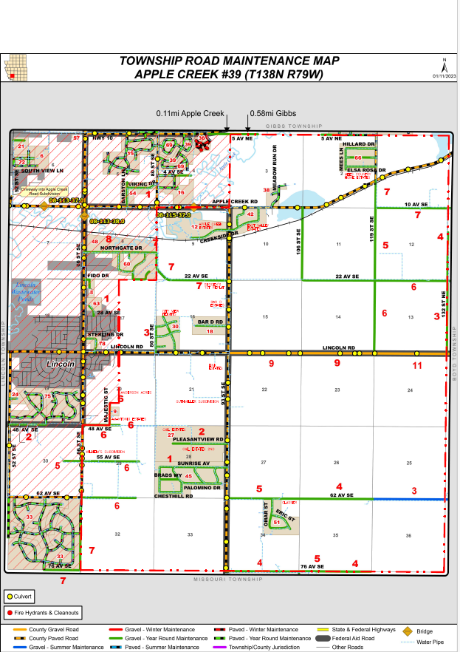

Date of Adoption Apple Creek Township Board of Supervisors ChairmanBottom of Form